Teaching Management System

Requirements Specification

Version 2.0

May 1, 2019

Enriko Smoqi
Edit Dollani
Murat Doka
Denisa Cenaj
Table of Contents
1. Executive Summary 3
1.1 Project Overview 3
1.2 Purpose and Scope of this Specification 3
2. Product/Service Description 3
2.1 Product Context 3
2.2 User Characteristics 3
2.3 Assumptions 3
2.4 Constraints 3
2.5 Dependencies 4
3. Requirements 4
3.1 Functional Requirements 5
3.2 Non-Functional Requirements 5
3.2.1 User Interface Requirements 5
3.2.2 Usability 5
3.2.3 Performance 6
3.2.4 Manageability/Maintainability 6
3.2.5 System Interface/Integration 7
3.2.6 Security 8
3.2.7 Data Management 8
3.2.8 Standards Compliance 8
3.2.9 Portability 8
3.2.10 Other Non-Functional Requirements 9
3.3 Domain Requirements 9
4. User Scenarios/Use Cases 9
APPENDIX 10
Appendix A. Definitions, Acronyms, and Abbreviations 10
Appendix B. References 10
Appendix C. Requirements Traceability Matrix 10
Appendix D. Organizing the Requirements 12

Executive Summary

Project Overview
This product’s purpose is to coordinate and manage schools from first grade up until ninth grade in a more efficient way by having a platform with all the different information in one giant web application which will contain all the necessary information for the intended audience that are both the school staff and the pupils/guardians (exp. Timetable, Grades, Attendance, Plans, Personal Information, etc.). The main goal of the product is to get rid of all the different papers, notebooks and confusion raised on the staff part and create transparency between the pupils and their respective teachers.

Purpose and Scope of this Specification
As mentioned before its intended audience is the is the staff of the school (such as the headmaster along with the teachers), the pupils and their guardians. The product will establish a better, easier and more effective communication way for the principal, teachers, pupils and their guardians. This product the teachers can organize their lesson planners, registers, easily access their timetable and reach their pupils more easily either to make announcements or to engage them in discussions. The pupils can quickly access their grades with no need to ask the teachers constantly and the principal can easily collect the lesson planners and fix the timetable that is to be shared with the teachers and pupils.
Within the scope:
- Program wireframing and schemes based on the contact with the client and discussion on their preferences.
- Various system users (Headmaster, Teacher, Pupil, Parent) with different functionalities.
- Confirming usage of the program according to the school materials and information.
- Calculation of grades, automatic register maker and protection of the user data.
- Explanation on details of the program, how it is used for each system user.

Outside of the scope:
- Later changes and updates (in case of not being mentioned before).

Product/Service Description

Product Context
We are dealing with an independent and self-contained product.

User Characteristics
A total of 5 users will interact with the system:
Headmaster:

- Can log in to his account
- Can read and modify his personal information (name, surname, birthday, etc.)
- Is able to add and remove guardians, pupils and teachers
- Access to read and modify the personal data (name, birthday, etc.) of teachers, guardians and pupils

- Can collect, see and modify attendance, grades, assignment, plans, exams, timetable and any other kind of information on those 3 users
- Can log out of their account
- All characteristics of the teacher user too.

Teacher:

  - Can log in to their account
  - Has access to his personal information (name, birthday, etc.)
  - Able to add and remove guardians and pupils
  - Has access to the information of pupils and guardians.
  - Fill pupils attendance and grades.
  - Give assignment and collect them
  - Access to read and modify their own plans, diary, registers, exams and calendar
  - Can deny or accept meeting
  - Can log out of their account

Pupils:
  - Can log in to his account
  - Has access to his personal information(name, birthday, etc.)
  - Access to see their own grades, attendance, calendar (exams, due homework, etc.)
  - Able to see assignments given and to submit their homework
  - Can log out of their account

Guardians:
  - Can log in into his account
  - Access to read their personal data (name, birthday, etc.)
  - Able to see their pupil’s grades, attendance and calendar
  - Can request a meeting with the teacher
  - Can log out of their account

Administrator:

  - Can log in into his account
  - Able to access all the user data
  - Able to modify users personal information
  - Able to add and remove headmaster
  - Can log out

Assumptions
The main assumption affecting the requirements would be the availability of the internet since it is a web based application. Other than that some minor assumptions would be:

- Changing the administrator or changing the headmaster(dependent on the admin since only he can change that)
- In case of the need to change any personal info the administrator has to be contacted(depending on the specific privileges)
- Training for teachers and headmaster to use the product

Constraints
Because it is a web application the only and crucial constrain is a good internet connection so the data requested can be fetched and the product won’t be sluggish.

Dependencies
The main dependency of the system is that it needs an administrator since only he can add a headmaster which will make the product fully work.

Requirements

Functional Requirements
Req# | Requirement | Comments | Priority | Date Rvwd | SME Reviewed / Approved
BR_LR_01 | Consist of different users | Each user has a different view of the product
BR_LR_02 | reCaptcha for added security | To verify that the user is not a robot
BR_LR_03 | Each user should have a password and able to modify it | Hashing the password before sending it over to the database for added security
BR_LR_04 | Some users should be able create, delete or modify users | Having a CRUD function for Admin, Headmaster and teacher
BR_LR_05 | Create, modify and collect plans, diaries and registers | Teacher should be able to create and modify them while headmaster can collect them all as well
BR_LR_06 | Guardians and pupils cannot see other users data (personal info, grades, etc) | Pupils and guardians should only see their information (and only their pupils information)
BR_LR_07 | Each user will have a specific clearance | To give access to sensible information/data only to the specified users

Non-Functional Requirements

User Interface Requirements
- Log in
  - A simple page which will require an username and a password
  - Able to change password if the user has forgotten it
  - If the users IP is suspicious a reCaptcha will appear to make sure it is not a robot
  - reCaptcha should be able to protect the application from spam and abuse
- Guardian
  - Buttons which will redirect them to their personal info, their pupils attendance and grades
  - A button to see the calendar for upcoming exams or due date for homework
- Pupil
  - Buttons which will redirect them to their personal info, attendance and grades
  - Button to redirect them to check if they have any assignment
    - A list shown of homework he/she has due and able to open them
    - A button to download that specific assignment
    - Button to upload his homework to that specific assignment
- Teachers:
  - Buttons which will redirect them to their personal info, attendance and grades
  - “Assignment” should send him to a page where he can give an assignment and be able to collect all the submitted solutions.
  - “Plan” where he should be able to create, delete and modify his/her own lesson plan
  - “Calendar” he/she will be able to see all the dates and add “events” to them which will show on all the calendars. Events can be anything from exam day, to due homework or a special occasion
  - “Grades” it should show all his/her pupils and he/she can add, remove and modify each pupil grades
  - “Attendance” shows all his/her pupils and able to add to all at once their attendance
- Headmaster:
  - All the teachers interface with an added button on Diary, Plan, Register, Attendance, Grades which collects all the of the teachers information on that specific page
  - “Profile Manager” redirecting him/her to a page where he/she can add or remove a teacher. If he is adding a form will appear which he/she needs to fill the required spaces.
  - Can edit users personal information
- Administrator:
  - All the Headmasters interface
  - “Add/Remove Headmaster” redirecting him/her to a page where he/she can add or remove a teacher. If he is adding a form will appear which he/she needs to fill the required spaces.
  - Can edit users personal information

Usability
The product is easy to use since the main functions will be displayed on the screen without cording the user with way too many options which he won’t use. Most of the users need little to no training to be able to use the program and the user will have it easy to pick it back up after a long time of not using the system. For any kind of errors, the users will be able to modify them quickly or just simply remove them. If a user tries to delete something which is related to other stuff, it won’t be able to do that unless he is an administrator and he will be warned before he does it.

Performance

Capacity
Every user will be using the same database. If there are a lot of request going at the same time at the database there might be a slight delay which should be negligible. There won’t be used a lot of memory since most of the users just share the same data.

Availability
The product should be available 24/7 and everyone should be able to access it at any time of the day as long as they have a computer and an internet connection. The product won’t be forced to need any kind of down time and if there is any kind of maintenance it should be around an hour or so.

Latency
There should be a very little latency from this application.

Manageability/Maintainability

Monitoring
Everything will be logged and both the Headmaster and Administrator will be able to see the logs of all the modified, added or removed data.

Maintenance
The product should be developed with modules making it easy to maintain any kind of problem it might give or to extended upon them for added functionality.

Operations
There will be CRUD for mostly everything. Able to access data other data (if they have clearance for that). To be able to login and view their information.

Security

Protection
- Sensitive data will be hash encrypted (password).
- Users activity will be logged for any king of error they might create.
- reCaptcha to protect the server for spams or abuse.
- Format every string so no kind of injection will be made (from forms to everything else)

Authorization and Authentication
- Users will be authenticated using password and username
- User type authorization, giving access only to their respective information
- Using session and cookies to keep track of users

Standards Compliance
Most of the users activity will be traced so if any problem occurs it will be able to be traced back to the corresponding user/person.

Portability
The product is web based, therefore it will operate on any operating system.

User Scenarios/Use Cases
- Scenarios
ADMIN
Scenario #1:
Adding Teacher, Headmaster, Pupils, Guardian

Actors:
Administrator

Start state:
- Administrator is logged into the system

Scenario flow:
- The administrator clicks on the “Profile Management” button
- Clicks on the “Add User” button
- Fills in the name, surname and all other information it requires
- Selects users type from the drop down list
- Clicks “Add” button after filling the necessary fields

End State:
- The user is added

Scenario #2:
Turning Teacher to Headmaster

Actors:
Administrator

Start state:
- Administrator is logged into the system

Scenario flow:
- The administrator clicks on the “Profile Management” button
- Clicks on the “Edit” button of the desired teacher (Can use the search to find it faster)
- Changes that person from teacher to headmaster with a drop down list
- Clicks “Submit” button to finalize the action

End State:
- A specific teacher is turned into a headmaster

Scenario #3:
Turning Headmaster to Teacher

Actors:
Administrator

Start state:
- Administrator is logged into the system

Scenario flow:
- The administrator clicks on the “Profile Management” button
- Clicks on the “Edit” button of the headmaster
- Changes that person from headmaster to teacher with a drop down list
- Clicks “Submit” button to finalize the action

End State:
- The headmaster is turned into a teacher
Scenario #4:
Deleting Headmaster, Guardian, Pupils, Teacher

Actors:
Administrator

Start state:
- Administrator is logged into the system

Scenario flow:
- The administrator clicks on the “Profile Management” button
- Clicks on the user profile
- Clicks “Edit” button
- Clicks “Delete” button
- User gets prompted of the action and to confirm his action
- Clicks “Confirm” button

End State:
-The user is deleted

Scenario #5:
Editing Teacher, Pupil, Guardian, Headmaster Information
Actors:

Administrator

Start state:
- Administrator is logged into the system

Scenario flow:
- The administrator clicks on the “Profile Management” button
- Clicks on the desired user profile (Can use the search to find it faster)
- Clicks “Edit” button
- All the user information is showed and can be edited willingly
- User gets prompted of the action and to confirm his action
- Clicks “Confirm” button

End State:
- Users information is edited
HEADMASTER
Scenario #1:
Adding Teacher, Pupil, Guardian
Actors:
Headmaster
Start state:
- Headmaster is logged into the system

Scenario flow:
- The headmaster clicks on the “Profile Management” button
- Clicks on the “Add User” button
- Fills in the name, surname and all other information it requires
- Selects user type from the drop down list
- Clicks “Add” button after filling the necessary fields

End State:
- The user is added

Scenario #2:
Editing Teacher, Pupil, Guardian Information

Actors:
Headmaster

Start state:
- Headmaster is logged into the system

Scenario flow:
- The Headmaster clicks on the “Profile Management” button
- Clicks on the desired user profile (Can use the search to find it faster)
- Clicks “Edit” button
- All the user information is showed and can be edited willingly
- User gets prompted of the action and to confirm his action
- Clicks “Confirm” button

End State:
- User information is edited

Scenario #4:
Deleting Guardian, Pupil, Teacher
Actors:
Headmaster

Start state:
- Headmaster is logged into the system
Scenario flow:
- The Headmaster clicks on the “Profile Management” button
- Clicks on the desired profile (Can use search to find it faster)
- Clicks “Edit” button
- Clicks “Delete” button
- User gets prompted of the action and to confirm his action
- Clicks “Confirm” button

End State:
- The user is deleted

GUARDIAN

Scenario # 1:
Check grades

Actors:
Guardian

Start state:
- Guardian is logged into the system

Scenario flow:
- The user clicks the "Grade" button
- After clicking the button, the photo, name and surname of corresponding pupil will be shown to the guardian
- The guardian will click over the photo, a table of all the subject and the grades of the pupil will be opened

End state:
The guardian checks the grades of the pupil
Scenario # 2:
Check attendance

Actors:
Guardian

Start state:
- User is logged into the system

Scenario flow:
- Guardian clicks on the "Attendance" button
- After clicking the button, the photo, name and surname of corresponding pupil will be shown to the guardian
- By clicking the photo of the child, the attendance of subjects and the corresponding year will be opened

End state:
Guardian checks the attendance

Scenario # 3:
Look Timetable
Actors:
Guardian
Start state:
- User is logged into the system
Scenario flow:
- Guardian click on the "Timetable" button
- A calendar shows and below it, it shows the pupil/s of the guardian and their/its respective timetable

End state:
Guardian looked the timetable

PUPIL
Scenario #1:
Check Grades

Start state:
- User is logged into the system

Scenario flow:
- The user clicks the "Grade" button
- After clicking the button, all the subject and the corresponding year will be shown
- By clicking to the subject and corresponding year the grades of that subject will show

End state:
- Pupil check the grade

Scenario # 2:
Check attendance

Actors:
Pupil

Start state:
- User is logged into the system
Scenario flow:
- Pupil clicks on the "Attendance" button
- After clicking the button, the subjects and the corresponding year will be opened
- By clicking the subject pupil can see how many hours he was present on the class
End state:
Pupil check the attendance

TEACHER:
Scenario #1:
Seeing the Plan

Actors:
Teacher

Start state:
- Teacher is logged into the system

Scenario flow:
- Clicks on “Plan” button
- Clicks on the subject it wants
- A table shows the whole plan of the subject

End State:
- Teacher is informed of the plan

Scenario #2:
Modifying the Plan

Actors:
Teacher

Start state:
- Teacher is logged into the system

Scenario flow:
- Clicks on “Plan” button
- Clicks on the subject it wants
- A table shows the whole plan of the subject
- Clicks on the “Edit” button
- Edits the preferred information on the table by clicking on it

End State:
Teacher modified the plan

Scenario #3
Adding Diary
Actors:
Teacher

Start state:
- Teacher is logged into the system

Scenario flow:
- Clicks on “Plan” button
- Clicks on the subject it wants
- A table shows the whole plan of the subject
- Teacher clicks on the “Add” button on the desired row of the table
- A diary entry is created for that entry which he fills in the information
- Clicks “Submit” button

End State:
Teacher has added a diary entry to the desired plan

Scenario #4:
Modifying Diary
Actors:
Teacher

Start state:
- Teacher is logged into the system

Scenario flow:
- Clicks on “Plan” button
- Clicks on the subject it wants
- A table shows the whole plan of the subject
- Teacher clicks on the “Edit” button on the desired row
- Clicks the file to edit it or he can remove it and add a new one

End State:
Teacher has edited a diary entry to the desired plan

Scenario #5:
Add grade
Actors: Teacher

Start state:
-User is logged into the system
Scenario flow:
-Teacher click on the "Add grade" button
-Teacher should select the class
-After selecting the class the subject must me selected
-next to the subject is a plus button
-By clicking the button the teacher will fill the grades of all pupils

End state:
Teacher adds a grade for all pupil

Scenario #6:
Add grade of 1 pupil
Actors: Teacher

Start state:
-User is logged into the system
Scenario flow:
-Teacher click on the "Grade" button
-Teacher should select the class and the subject
-The list of all pupils will be shown and next to the name is a plus button that add the grade.
-Fills the filed required

End state:
Teacher submit the grade of each pupil

Scenario #7:
Deleting grade
Actors: Teacher

Start state:
-User is logged into the system
Scenario flow:
-Teacher click on the "Add grade" button
-Teacher should select the class and the subject and the desired pupil
-The list of all the class and corresponding grades will be opened
-Clicking “Edit” will show a X button next to the grade
-Click the X if the grade needs to be removed

End state:
The grade is removed for the desired pupil

Scenario # 8:
Editing Grade
Actors: Teacher

Start state:
-User is logged into the system
Scenario flow:
-Teacher click on the "grade" button
-Teacher should select the class and the subject and the desired pupil
-The list of all the class and corresponding grades will be opened
-Clicking the edit button will enable to edit the grade by clicking on it
-Teacher makes the necessary changes
-Clicks Confirm button

End state:
The grades of the corresponding pupil was edited by the teacher and resubmitted

Scenario #9:
Add attendance
Actors:Teacher

Start state:
- Teacher is logged into the system
Scenario flow:
- Click the “attendance” button
- Clicks on the class
- Next to the subject there is a “Add” button
- Clicking it will show a table with all the pupil of that class and having 2 tick boxes next to it and on top of the table 2 tick boxes which ticks all the boxes of each column
-Clicking submit will add attendance for that class on that subject the button was next to

End State:
Teacher add the attendance for each pupil one by one

Scenario #11:
Change attendance
Actors:Teacher

Start state:
- Teacher is logged into the system
Scenario flow:
- Click the “attendance” button
- Clicks on the subject and the class
- A table is shown with the name surname of the pupils
- Clicks on “edit” button to change the attendance
-Save the changes in the end of the table

End State:
Teacher edit the attendance of a pupil

Scenario #12:
Set Office Hour
Actors:Teacher

Start state:
- Teacher is logged into the system
Scenario flow:
- Click the “TimeTable” button
- A Calendar shows and below it his own weekly time table
- Clicking on the desired day on the calendar will open an hourly view of that day which he can select the hours he want’s and select from the drop down list “Office Hours” or if he desires add his own text
-Clicks “Submit” button

End State:
Teacher added office hours

Scenario #13:
Edit Office Hour
Actors:Teacher

Start state:
- Teacher is logged into the system
Scenario flow:
- Click the “TimeTable” button
- A Calendar shows and below it his own weekly time table
- Clicking on the desired day on the calendar will open an hourly view of that day which he can click on the already set event.
-This will give him the option to edit the hours or the text
-Clicks “Confirm”

End State:
Teacher edited office hours

Scenario #13:
Delete Office Hour
Actors:Teacher

Start state:
- Teacher is logged into the system
Scenario flow:
- Click the “TimeTable” button
- A Calendar shows and below it his own weekly time table
- Clicking on the desired day on the calendar will open an hourly view of that day which he can click on the already set event.
-This will give him the option to edit the hours or the text
-Clicks the “Delete” button
-Clicks “Confirm”

End State:
Teacher deleted office hours

- Use Cases
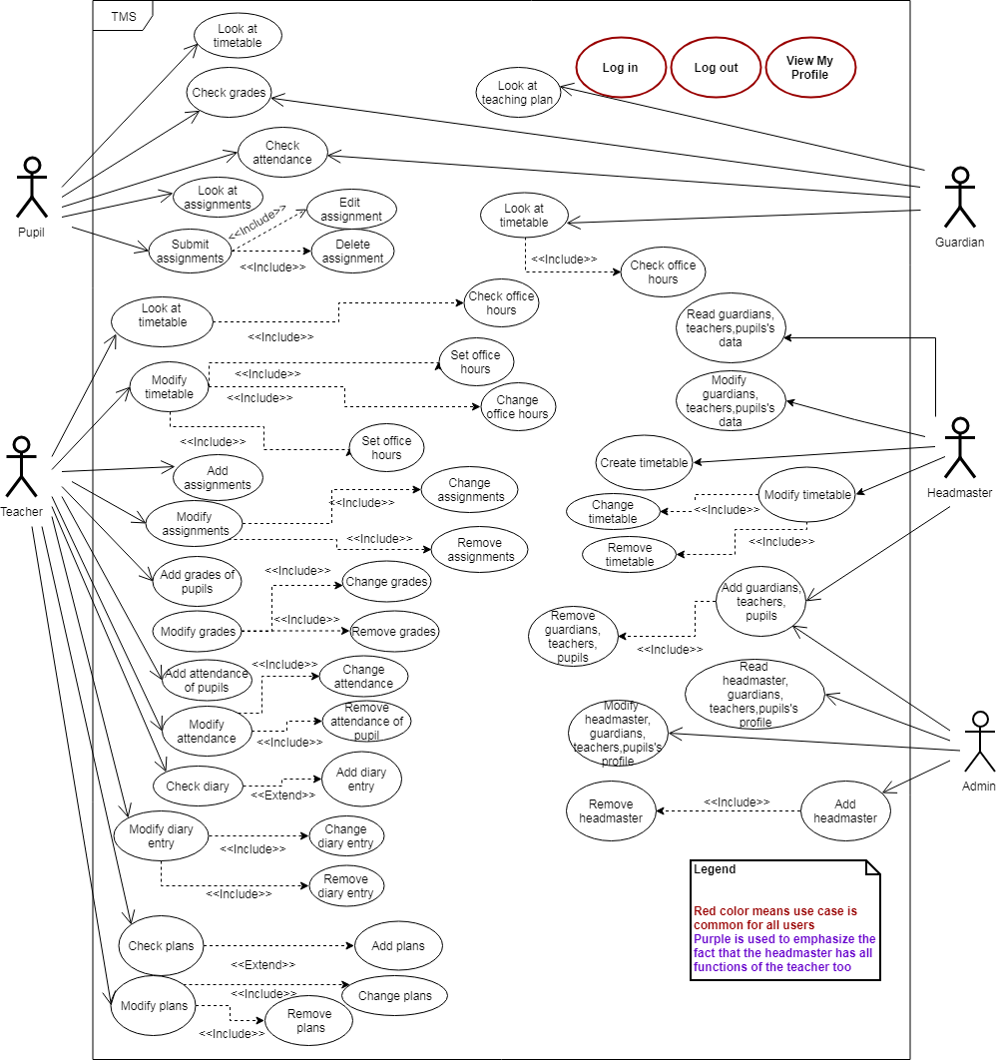

- Activity Diagrams

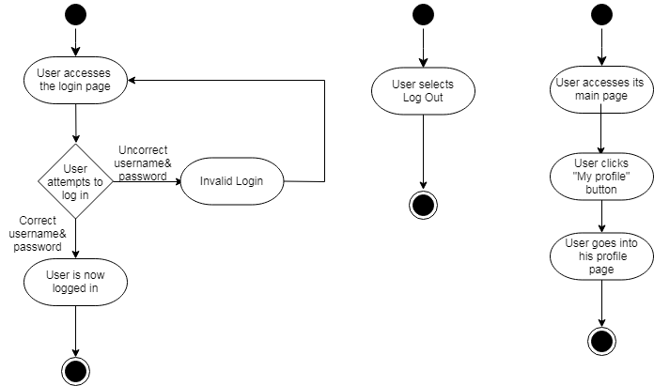

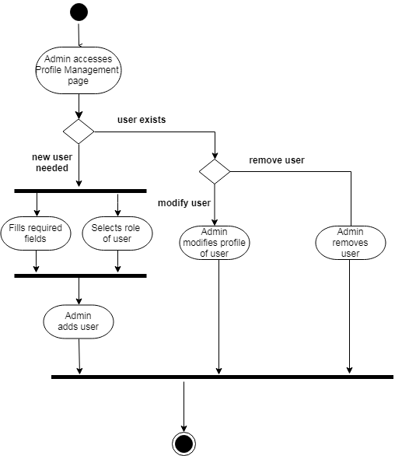

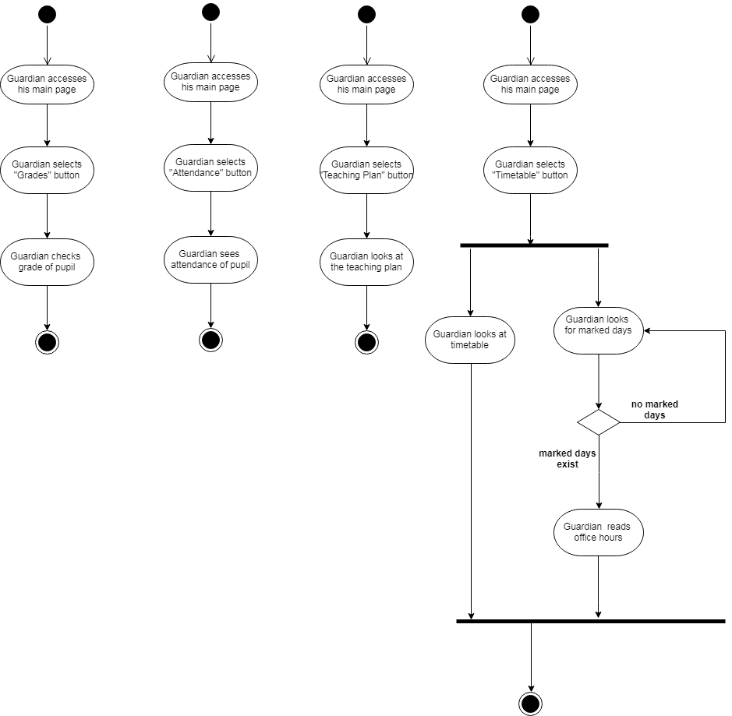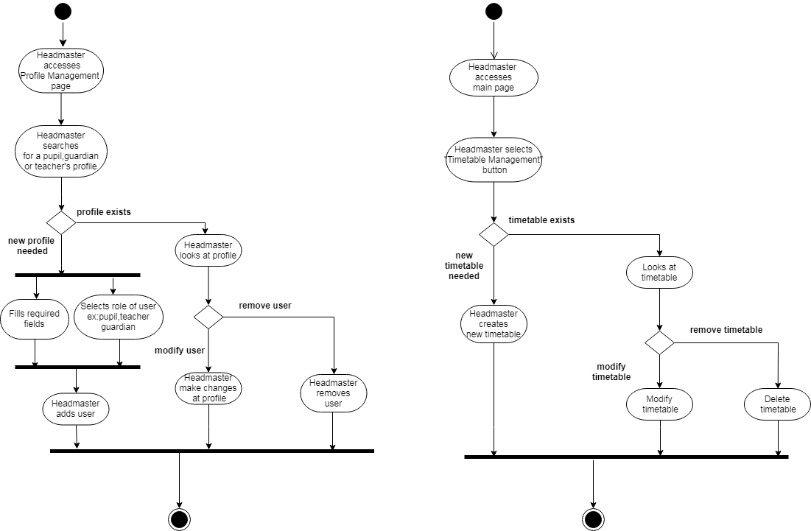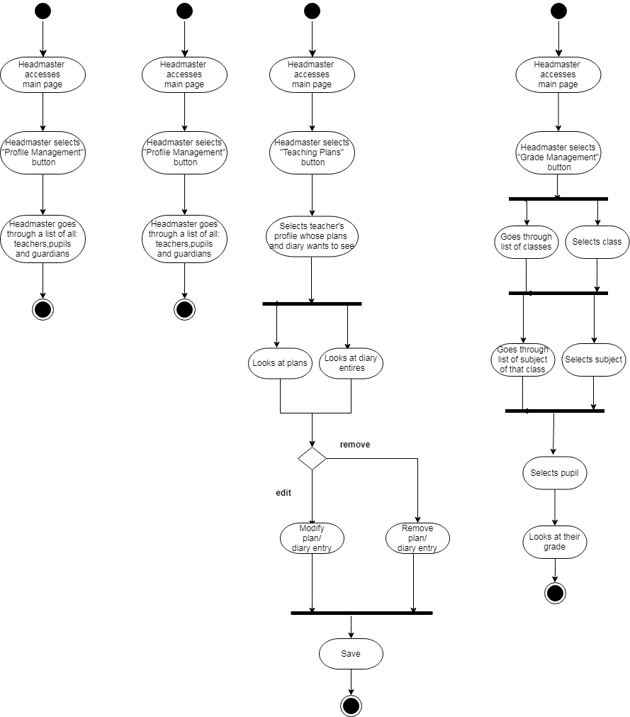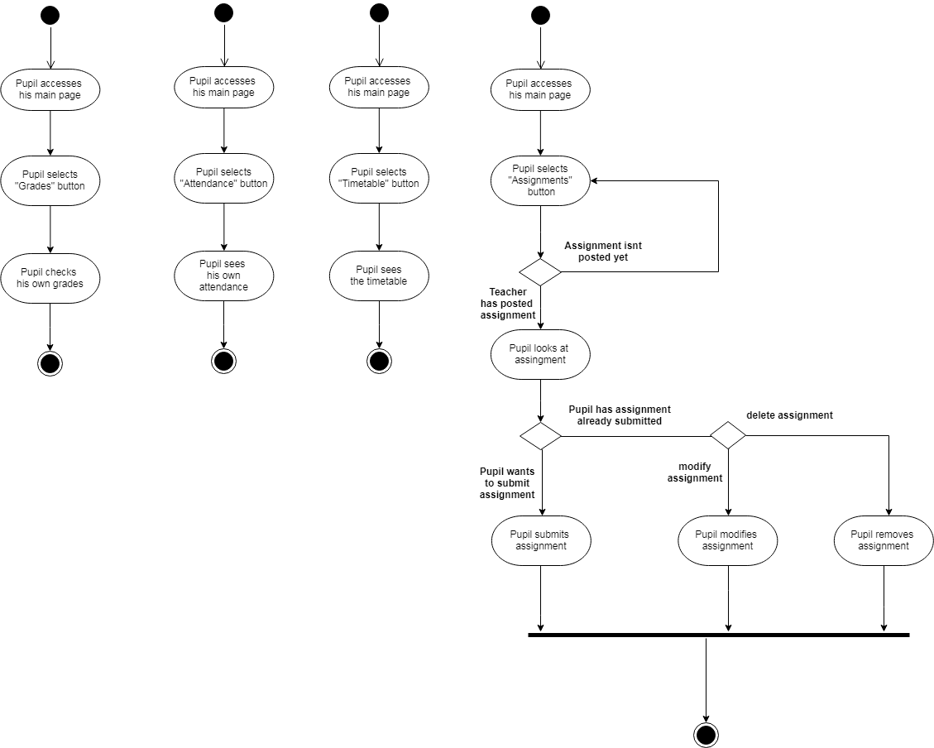
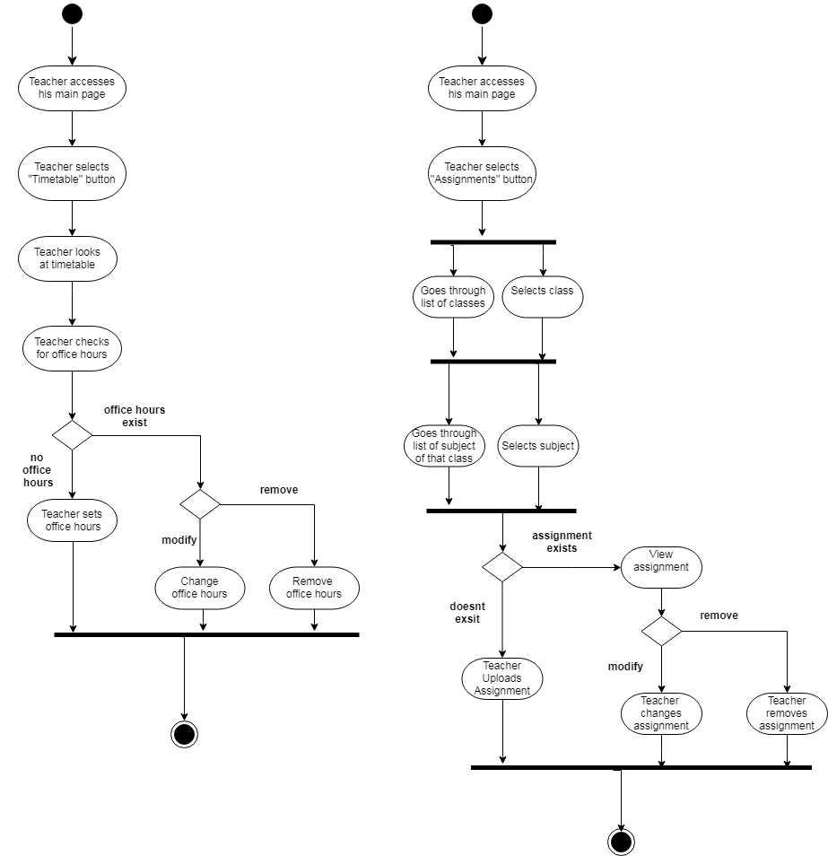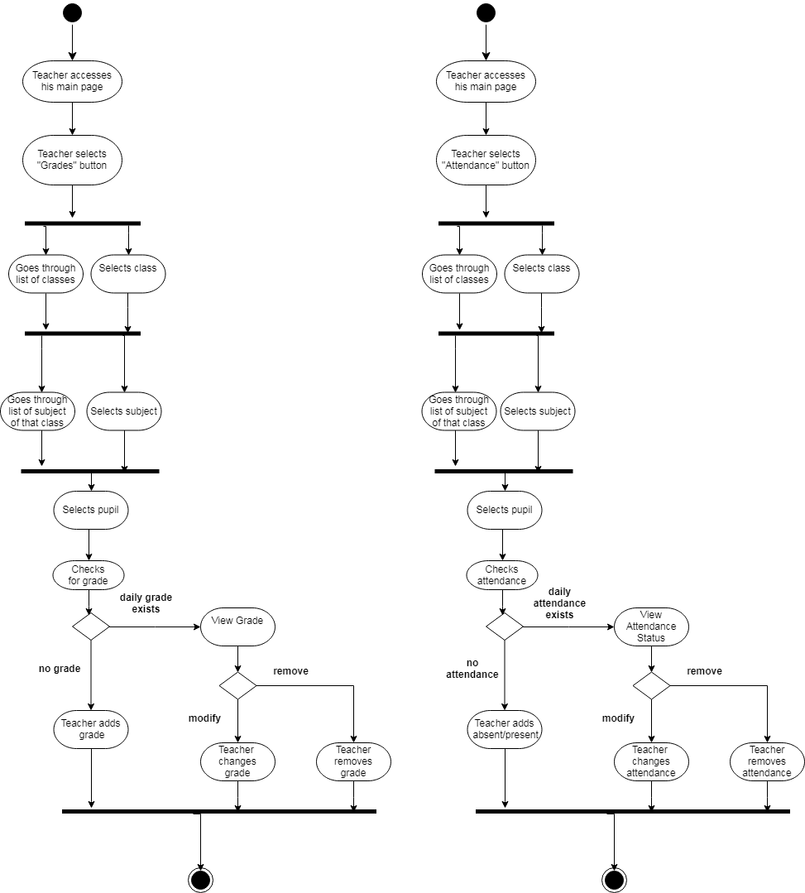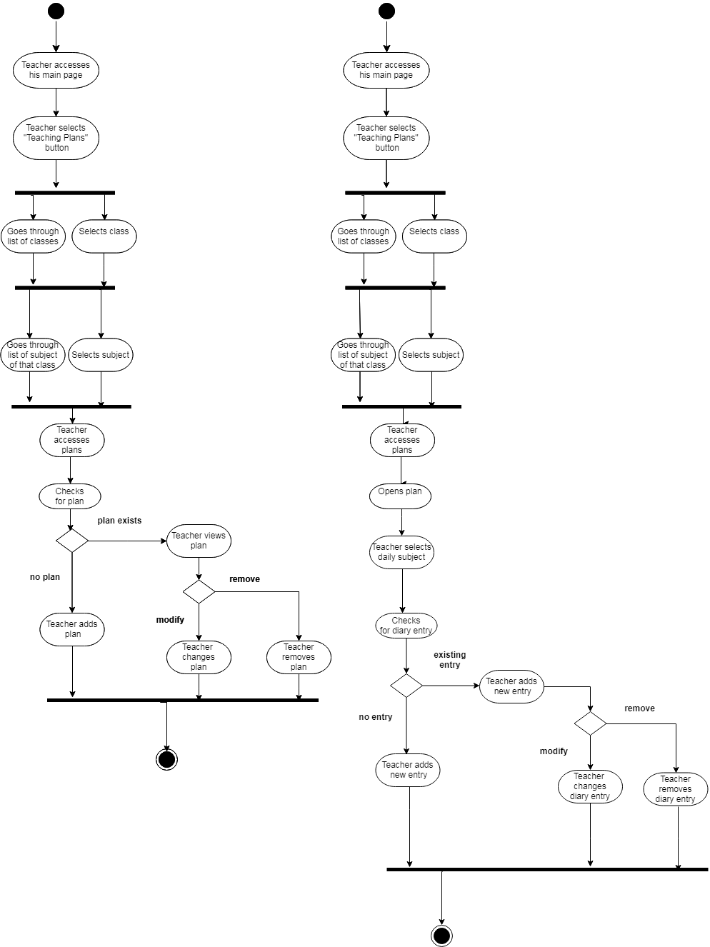

- Entity Relations Diagram

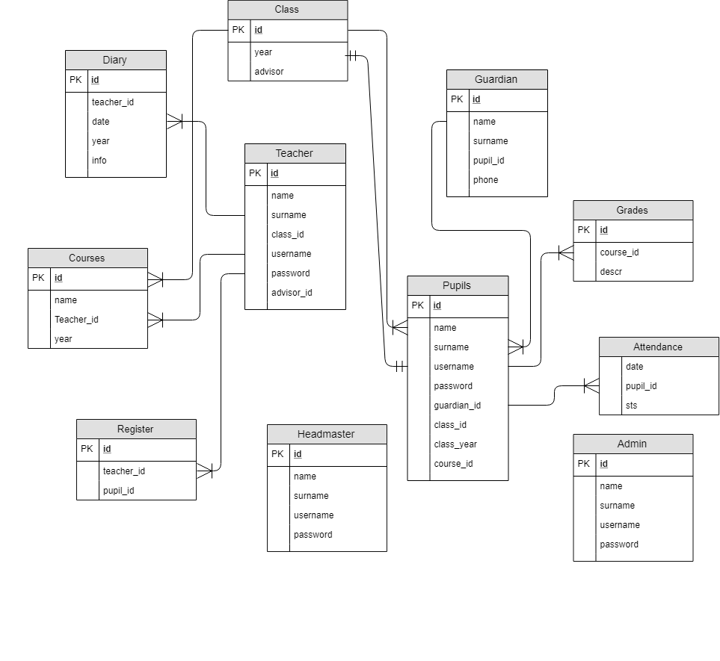

- Class Diagram

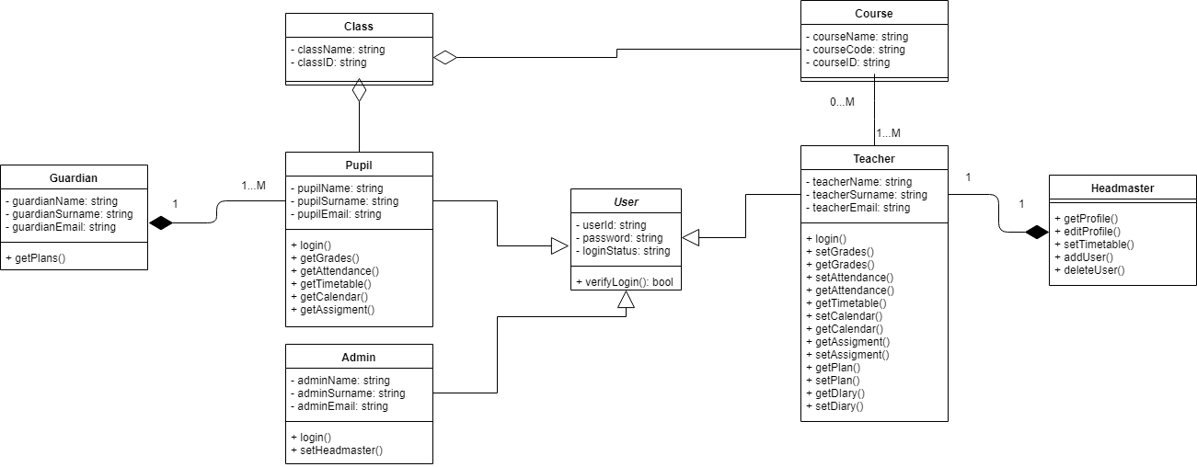

- DFD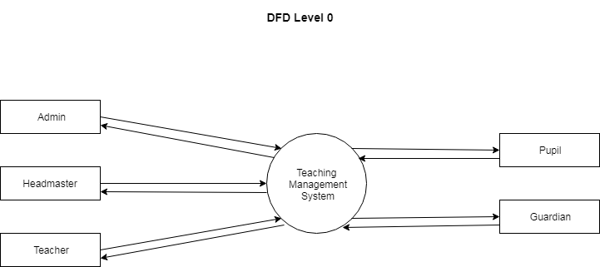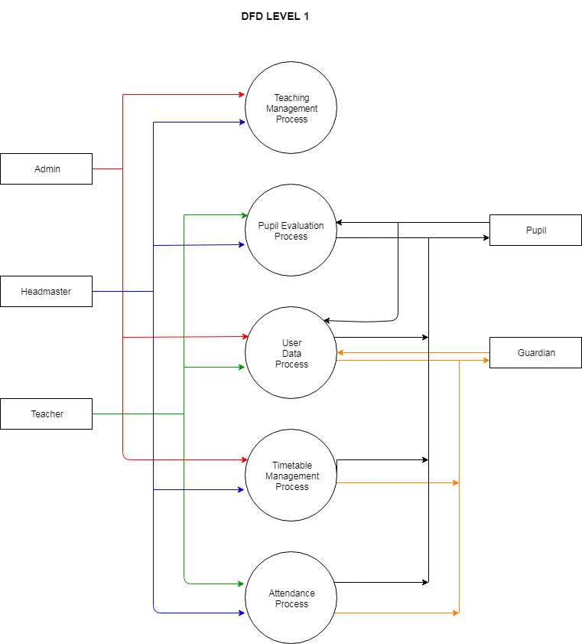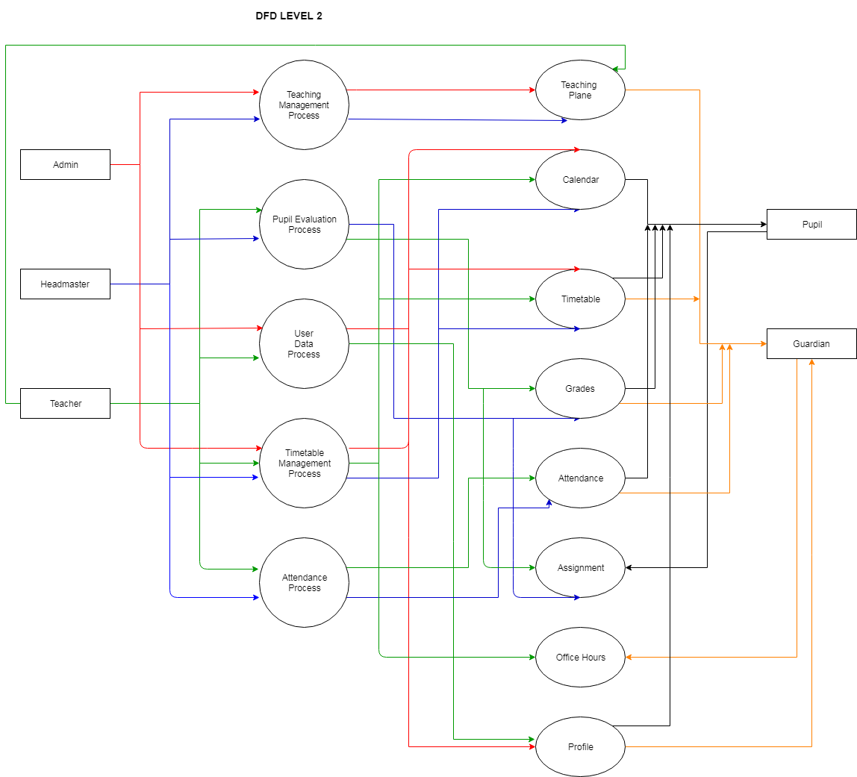

- State
- Sequential
- Collaboration
- Component

